**Project Deliverable 3**

**Project Steps:**

1. **Data Loading:** The code starts by loading the household electric power consumption dataset using Pandas from a local file.

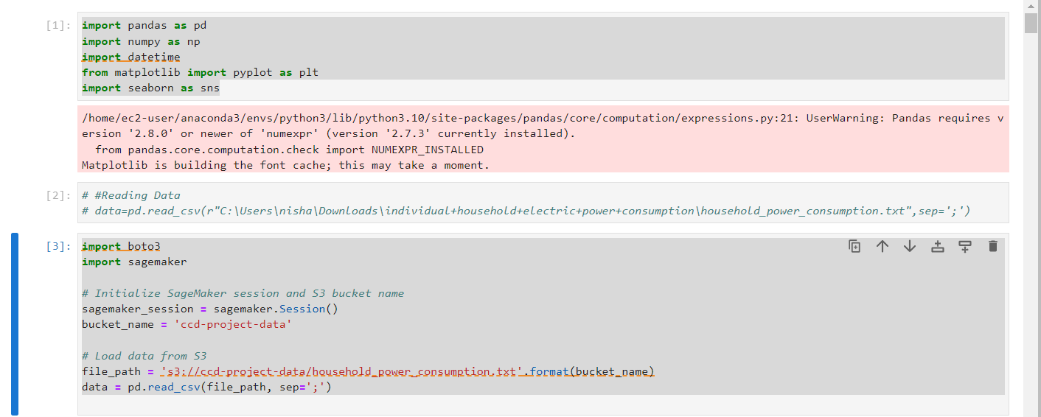

1. **Data Cleaning:** Handles missing values by replacing them with forward-fill in specific numeric columns.

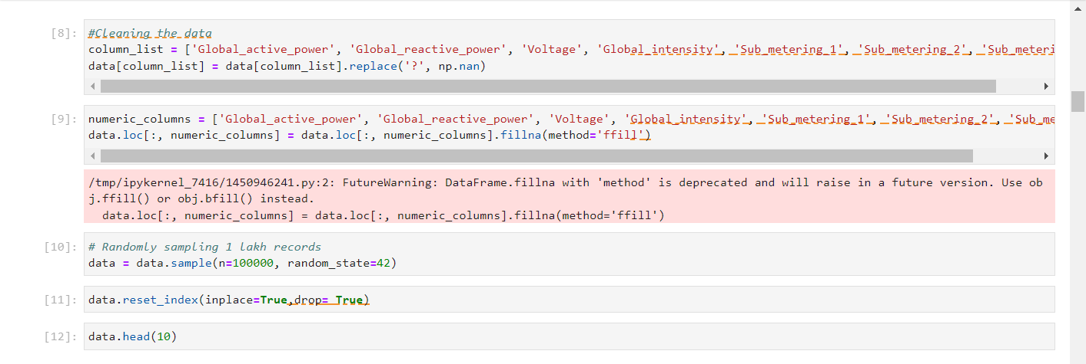

1. **Data Preprocessing:** Converts date and time columns to DateTime format and transforms object-type columns to numeric type where necessary.

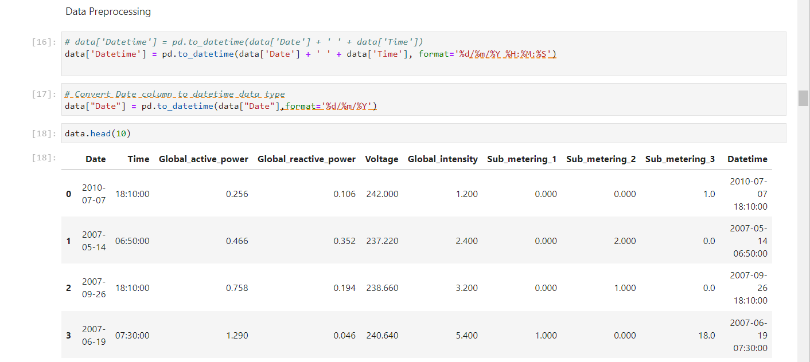

1. **Data Visualization:**
   * Generates histograms and boxplots for numeric columns to visualize their distributions and identify outliers.
   * Creates a correlation matrix heatmap to understand relationships between variables.

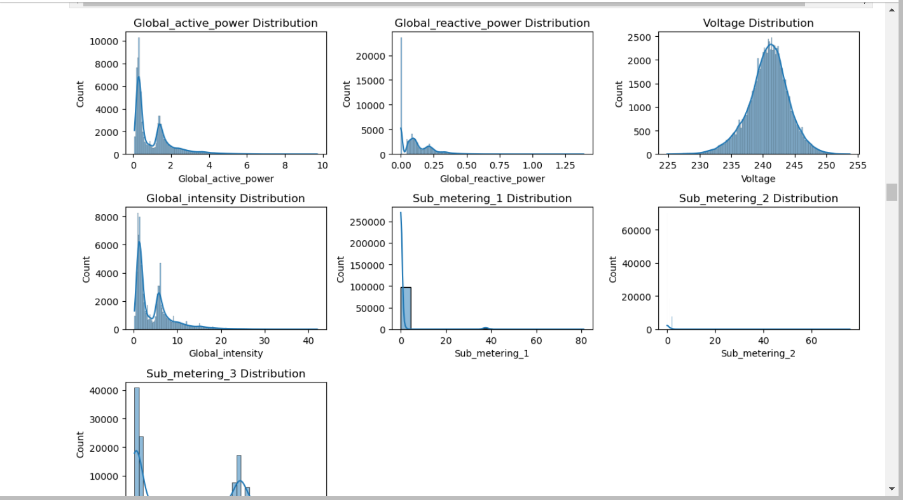

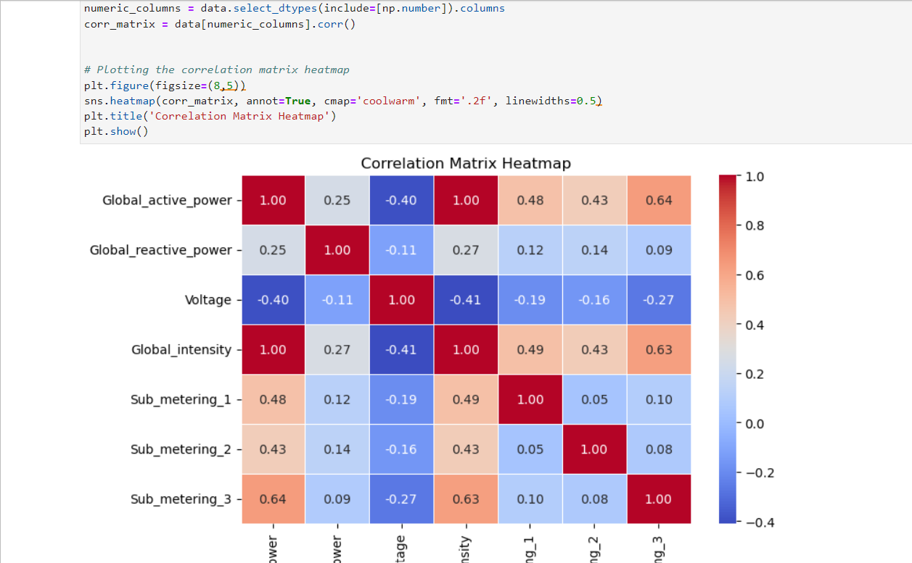

1. **Time Series Analysis:**
   * Performs time series forecasting using ARIMA and SARIMA models on the global active power.
   * Evaluates the forecasting models using metrics like MSE, RMSE, MAE, and MAPE.

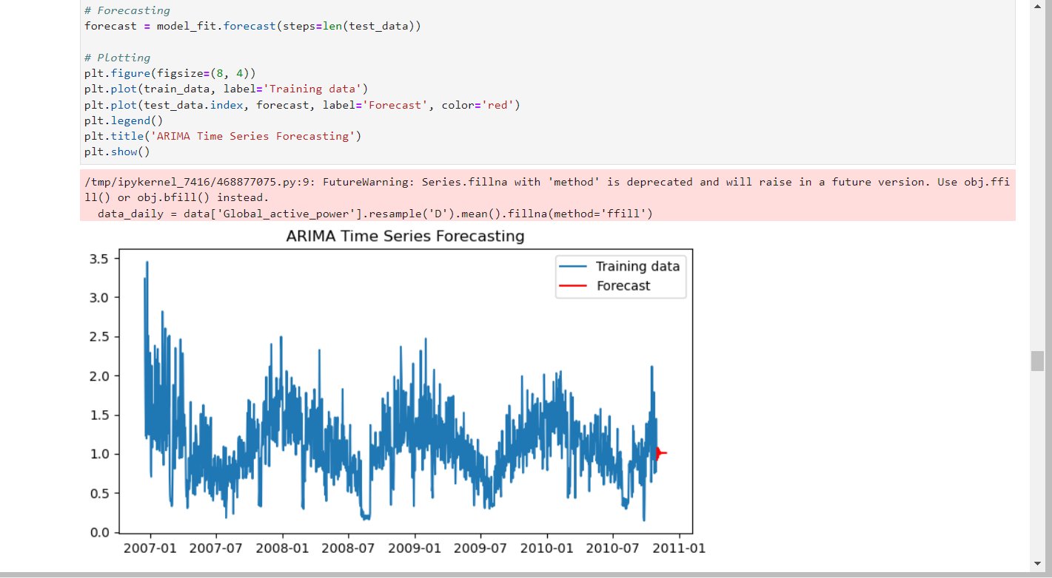

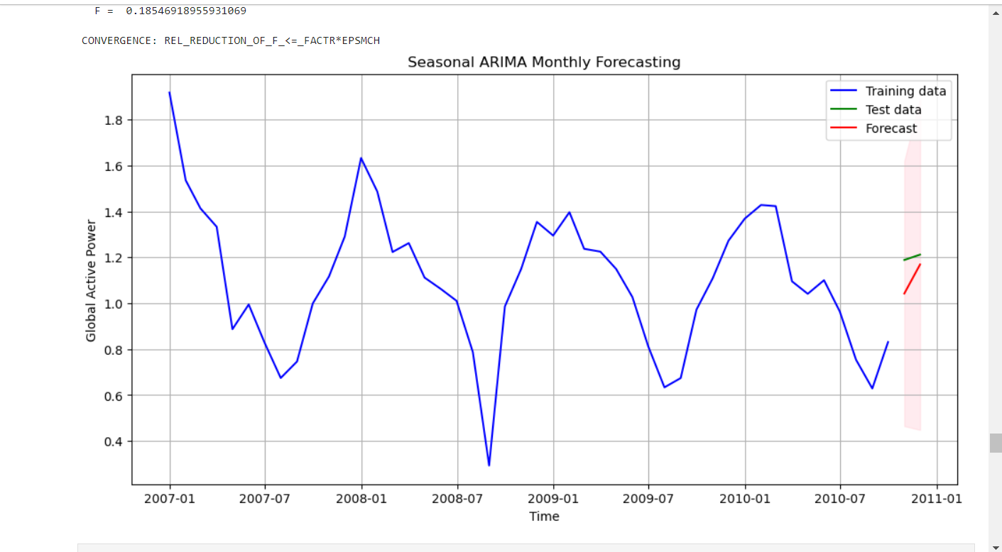

1. **Machine Learning:**
   * Utilizes Linear Regression, Gradient Boosting, and Random Forest Regression for predicting global active power.
   * Evaluates the models using metrics like MSE, MAE, and R-squared.

